 | 12 ATAR PHYSICS  2018_T4 Course Outline

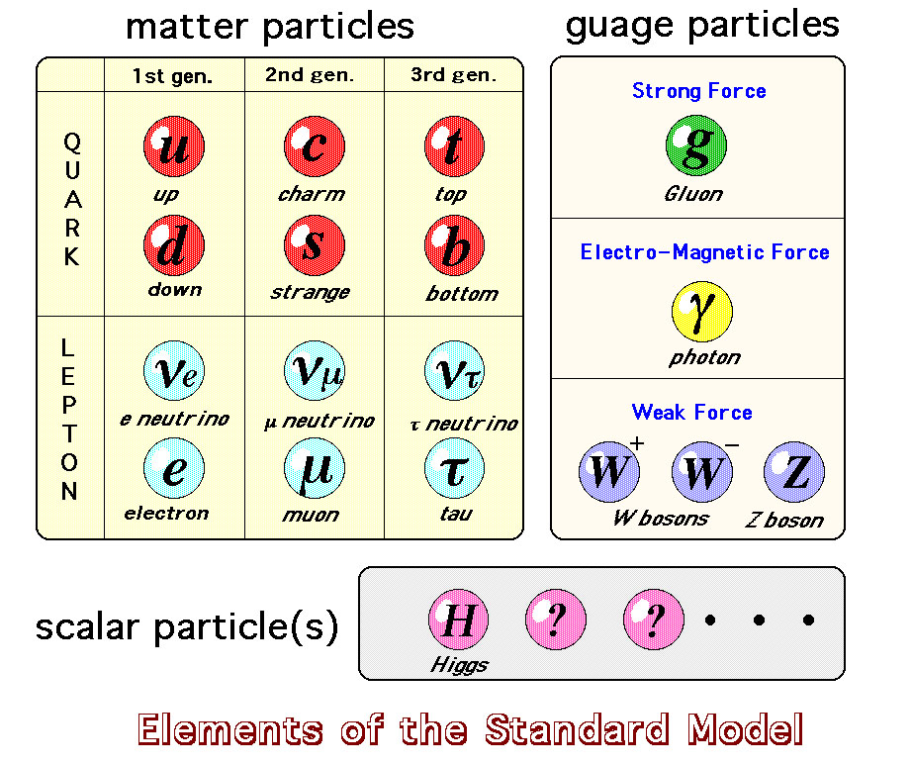

Unit content

An understanding of the Year 11 content is assumed knowledge for students in Year 12. It is recommended that students studying Unit 3 and Unit 4 have completed Unit 1 and Unit 2.

This unit includes the knowledge, understandings and skills described below. This is the examinable content.

Science Inquiry Skills

- Identify, research and construct questions for investigation; propose hypotheses; and predict possible outcomes.

- Design investigations, including the procedure to be followed, the materials required, and the type and amount of primary and/or secondary data to be collected; conduct risk assessments; and consider research ethics.

- Conduct investigations, including the manipulation of force measurers and electromagnetic devices, safely, competently and methodically for the collection of valid and reliable data.

- Represent data in meaningful and useful ways, including using appropriate Système Internationale (SI) units, symbols, and significant figures; organise and analyse data to identify trends, patterns and relationships; identify sources of uncertainty and techniques to minimise these uncertainties; utilise uncertainty and percentage uncertainty to determine the uncertainty in the result of simple calculations, and evaluate the impact of measurement uncertainty on experimental results; and select, synthesise and use evidence to make and justify conclusions.

- Interpret a range of scientific and media texts, and evaluate processes, claims and conclusions by considering the accuracy and precision of available evidence; and use reasoning to construct scientific arguments.

- Select, construct and use appropriate representations, including text and graphic representations of empirical and theoretical relationships, vector diagrams, free body/force diagrams, field diagrams and circuit diagrams, to communicate conceptual understanding, solve problems and make predictions.

- Select, use and interpret appropriate mathematical representations, including linear and non-linear graphs and algebraic relationships representing physical systems, to solve problems and make predictions.

- Communicate to specific audiences and for specific purposes using appropriate language, nomenclature, genres and modes, including scientific reports.

12 ATAR Physics assessment table - Type of assessment | Weighting
Science Inquiry  There must be at least one experiment, one investigation and one evaluation and analysis completed in this pair of units. Appropriate strategies should be used to authenticate student achievement on an out-of-class assessment task.  Experiment  Practical tasks designed to develop or assess a range of laboratory related skills and conceptual understanding of physics principles, and skills associated with representing data; organising and analysing data to identify trends and relationships; recognising error, uncertainty and limitations in data; and selecting, synthesising and using evidence to construct and justify conclusions.  Tasks can take the form of practical skills tasks, laboratory reports and short in-class tests to validate the knowledge gained.  Investigation  Activities in which ideas, predictions or hypotheses are tested and conclusions are drawn in response to a question or problem. Investigations can involve experimental testing, field work, locating and using information sources, conducting surveys, and using modelling and simulations.  Assessment tasks can take the form of an experimental design brief, a formal investigation report requiring qualitative and/or quantitative analysis of the data and evaluation of physical information, or exercises requiring qualitative and/or quantitative analysis of second-hand data.  Evaluation and analysis  Involves interpreting a range of scientific and media texts; evaluating processes, claims and conclusions by considering the accuracy and precision of available evidence; and using reasoning to construct scientific arguments.  Assessment tasks can take the form of answers to specific questions based on individual research; exercises requiring analysis; and interpretation and evaluation of physics information in scientific and media texts. |  | 20%
Test  Tests typically consist of questions requiring short answers, extended answers and problem solving.  This assessment type is conducted in supervised classroom settings. |  | 30%
Examination  Examinations require students to demonstrate use of terminology, understanding and application of concepts and knowledge of factual information. It is expected that questions would allow students to respond at their highest level of understanding.  Typically conducted at the end of each semester and/or unit and reflecting the examination design brief for this syllabus. This assessment type is conducted in supervised classroom settings. |  | 50%

Learning outcomes

By the end of this unit (U3), students:

- Understand that motion in gravitational, electric and magnetic fields can be explained using Newton’s Laws of Motion.

- Understand how the electromagnetic wave model explains the production and propagation of electromagnetic waves across the electromagnetic spectrum.

- Understand transformations and transfer of energy in electromagnetic devices, as well as transformations and transfer of energy associated with motion in gravitational, electric and magnetic fields.

- Understand how models and theories have developed over time, and the ways in which physical science knowledge and associated technologies interact with social, economic, cultural and ethical considerations.

- Use science inquiry skills to design, conduct, analyse and evaluate investigations into uniform circular motion, projectile motion, satellite motion and gravitational and electromagnetic phenomena, and to communicate methods and findings.

- Use algebraic and graphical representations to calculate, analyse and predict measurable quantities related to motion, gravitational effects and electromagnetic phenomena.

- Evaluate, with reference to evidence, claims about motion, gravity and electromagnetic phenomena and associated technologies, and justify evaluations.

- Communicate physics understanding using qualitative and quantitative representations in appropriate modes and genres.

Weekly Lesson Outline (2018)

Wk | Topic | Text Reference | Homework
T4_4 | Projectile motion  - Independent nature of horizontal and vertical motion  - Component nature of projectile motion  - Time of flight (TOF)  - Calculating speed in the horizontal and vertical plane | Pearson P46 – P62 | STAWA Exploring physics set 3  Pearson review 2.2, 2.3  DOT point 1.5
- The movement of free-falling bodies in Earth’s gravitational field is predictable
This includes applying the relationship s = vt, v = u+at, s = ut + 1/2at², v² = u² +2as, E_{k} = 1/2mv²
T4_5 | Parabola dynamics  - The half parabola  - The perfect parabola  - The imperfect parabola  - Quadratic nature of projectile motion | Pearson P46 – P62 | STAWA Exploring physics set 3  Pearson review 2.2, 2.3  DOT point 1.5
T4_6 | Projectile motion calculations  - Dynamics of parabolas  - Range and air resistance  - Speed of launch  - Angle of launch | Pearson P46 – P62
- Projectile motion can be analysed quantitatively by treating the horizontal and vertical components of the motion independently
This includes applying the relationships s = vt, v = u+at, s = ut + 1/2at², v² = u² +2as, E_{k} = 1/2mv²
Projectile & Circular Motion Test (5%)

Weekly Lesson Outline (2018)

Wk | Topic | Text Reference | Homework
T4_7 | Circular Motion in the horizontal plane  - Tension  - Friction  - Gravity  Centripetal acceleration  - Moving in a circle  - Forces acting on a turning body  Centripetal force in the horizontal plane  - Equations of circular motion  - Calculations with circular motion | Pearson P63 – P67 | STAWA Exploring physics set 4  Pearson review 2.4  DOT point 1.6
- When an object experiences a net force of const mag perpendicular to its velocity, it will undergo uniform circular motion, including circular motion on a horizontal plane and around a banked track; and vertical circular motion
This includes applying the relationships 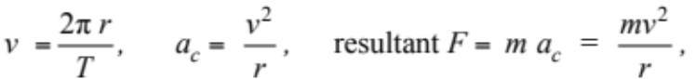
Circular Motion Experiment (5%)

T4_8 | Centripetal force in the vertical plane  Conical motion and Banked tracks | Pearson P63 – P86 | STAWA Set 5, P71  DOT 1.9, 1.10, 1.11
- When an object experiences a net force of const mag perpendicular to its velocity, it will undergo uniform circular motion, including circular motion on a horizontal plane and around a banked track; and vertical circular motion
This includes applying the relationships

Year 12 Physics – 2019

Assessment profile

Unit 3 |  |  |  | Unit 4
Assessment | Weight | Out of | Date | Assessment | Weight | Out of | Date
Science Inquiry |  |  |  | Science Inquiry
Circular motion experiment | 5% | 45 | Wk7_T4 (2018) | Experiment | 5% | 45 | Wk7_T3
Evaluation and analysis | 5% | 45 | Wk6_T1 | Investigation | 5% | 45 | Wk1_T3
Tests |  |  |  | Tests
Projectile & circular motion | 5% | 45 | Wk6_T4 (2018) | Atomic physics | 5% | 45 | Wk9_T2
Gravity, satellites & moments | 5% | 45 | Wk5_T1 | Relativity | 5% | 45 | Wk3_T3
Electromagnetism & EM induction | 5% | 45 | Wk5_T2 | Particles & cosmology | 5% | 45 | Wk6_T3
Examinations |  |  |  | Examinations
Semester One | 22% | 180 | Wk3_T2 | Semester Two | 28% | 180 | Term 3

